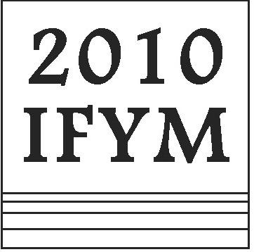
The Musicological Society of Japan
International Forum for Young Musicologists 2010
May 14-17, 2010, in Yokohama

Registration Form
Please complete this form (delete the items which are NOT applicable) and send it by e-mail to ifym-regis@ml.keio.jp as a file attachment.

Title: Mr. / Ms. / Dr. / Prof. other ( )

Name:

Mailing Address:

(Please use only the Roman alphabet, and include postal code and country. The pre-conference material will be sent to this address.)

E-mail Address:

Phone Number:

Institution:

Position:

Reception (19:00, Friday, 14th May 2010, Fee: 4,000 JPY)
I will attend/ I will not attend.

Excursion (17:00, Sunday, 16th – ca. 12:00 Monday 17th 2010, Fee: 13,400 JPY)
I will attend/ I will not attend.

Payment:
- Please select payment method:
Bank Account
Credit Card (participants from outside of Japan only)
- Date of the payment (day/month/year):

- Total Amount of your payment
(registration fee: 2,000 JPY, reception fee: 4,000 JPY, excursion fee 13,400JPY):

JPY

(If you choose payment with credit card, please download the “credit card payment form” from our website, complete and send by fax. Fax number is printed on the form. For security reasons please DO NOT send your credit card number by e-mail.)

